Tables:

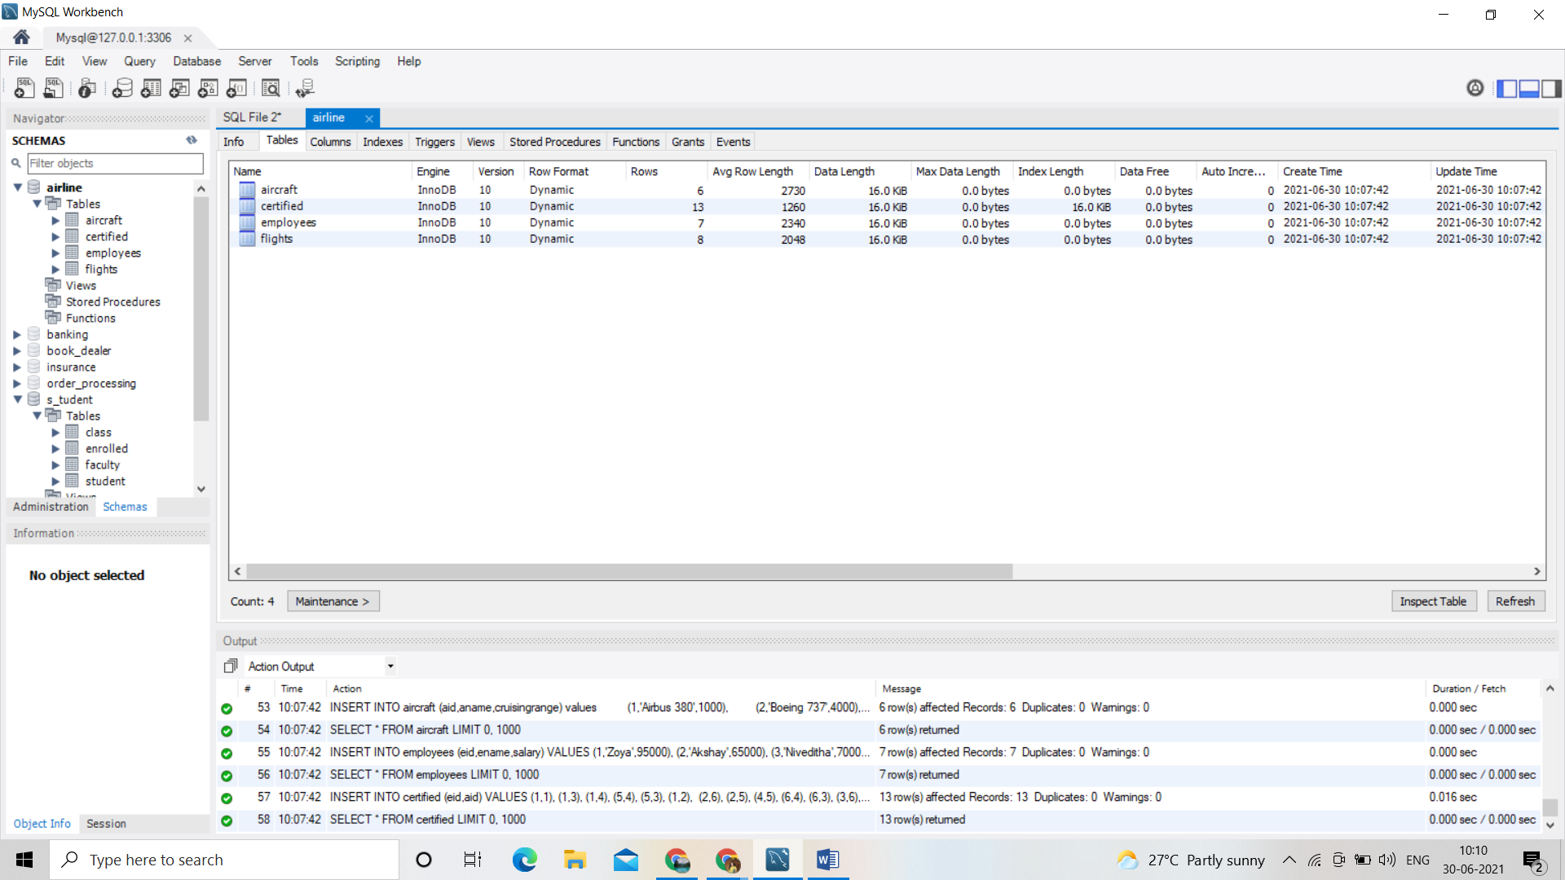

Columns:

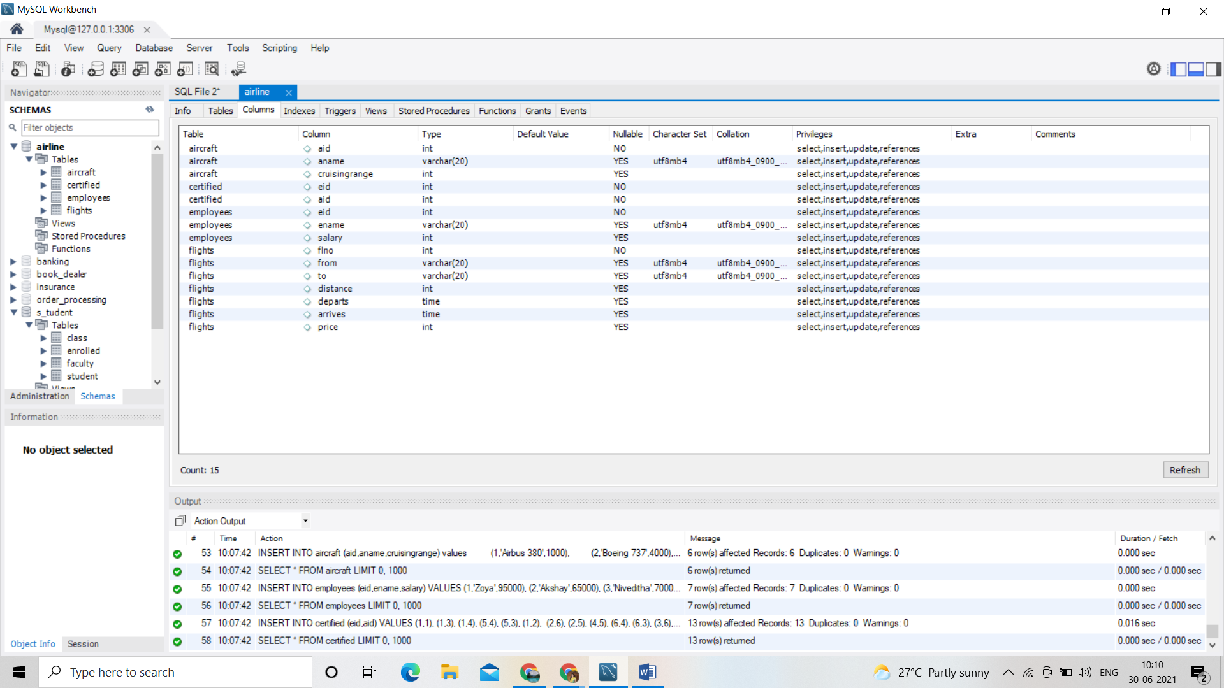

SELECT \* FROM airline.aircraft;

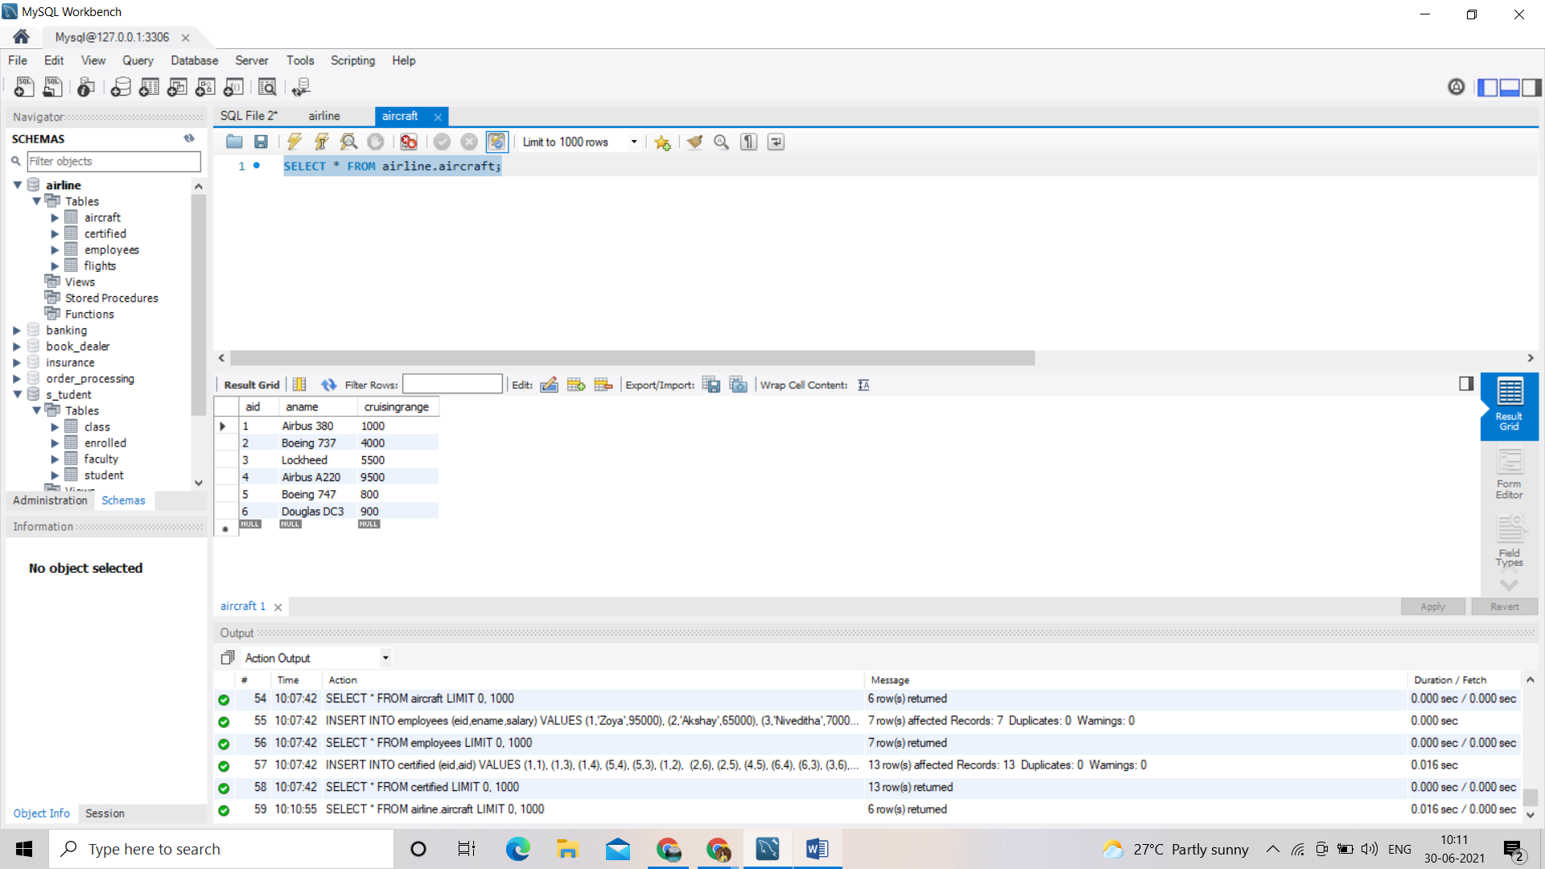

SELECT \* FROM airline.certified;

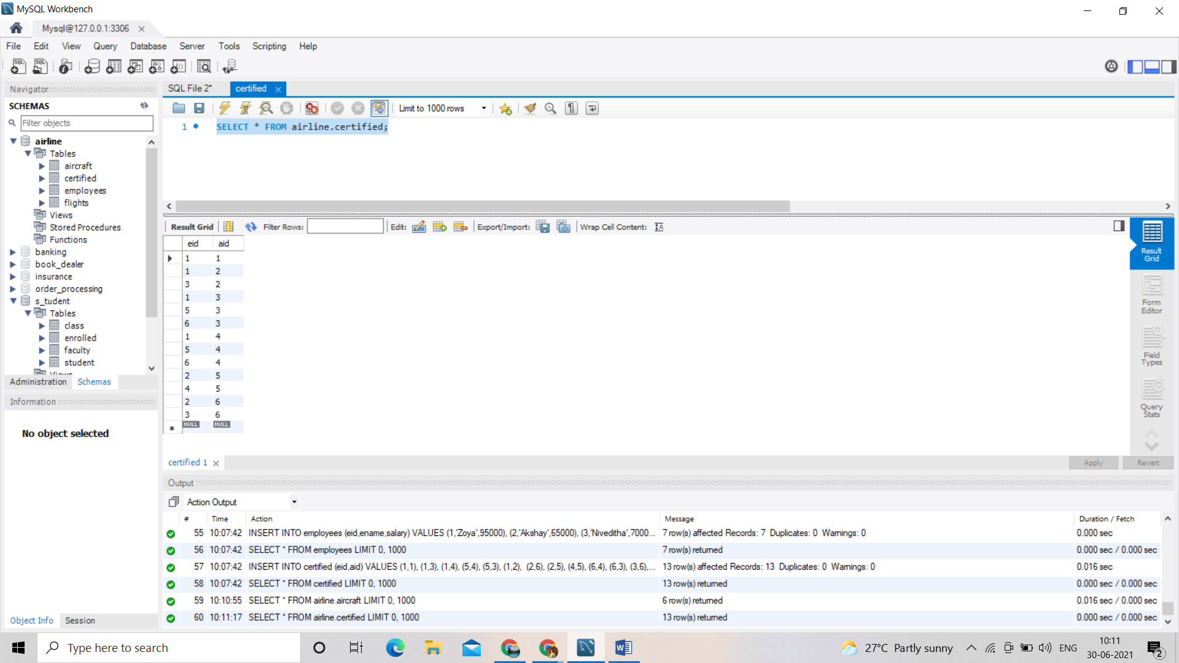

SELECT \* FROM airline.employees;

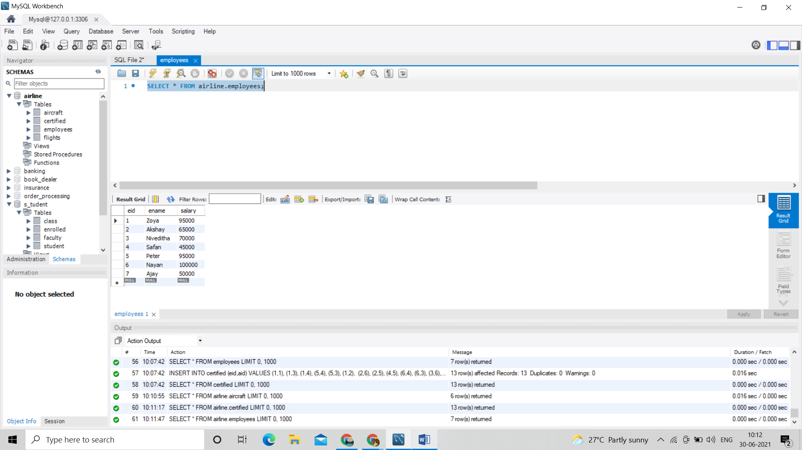

SELECT \* FROM airline.flights;

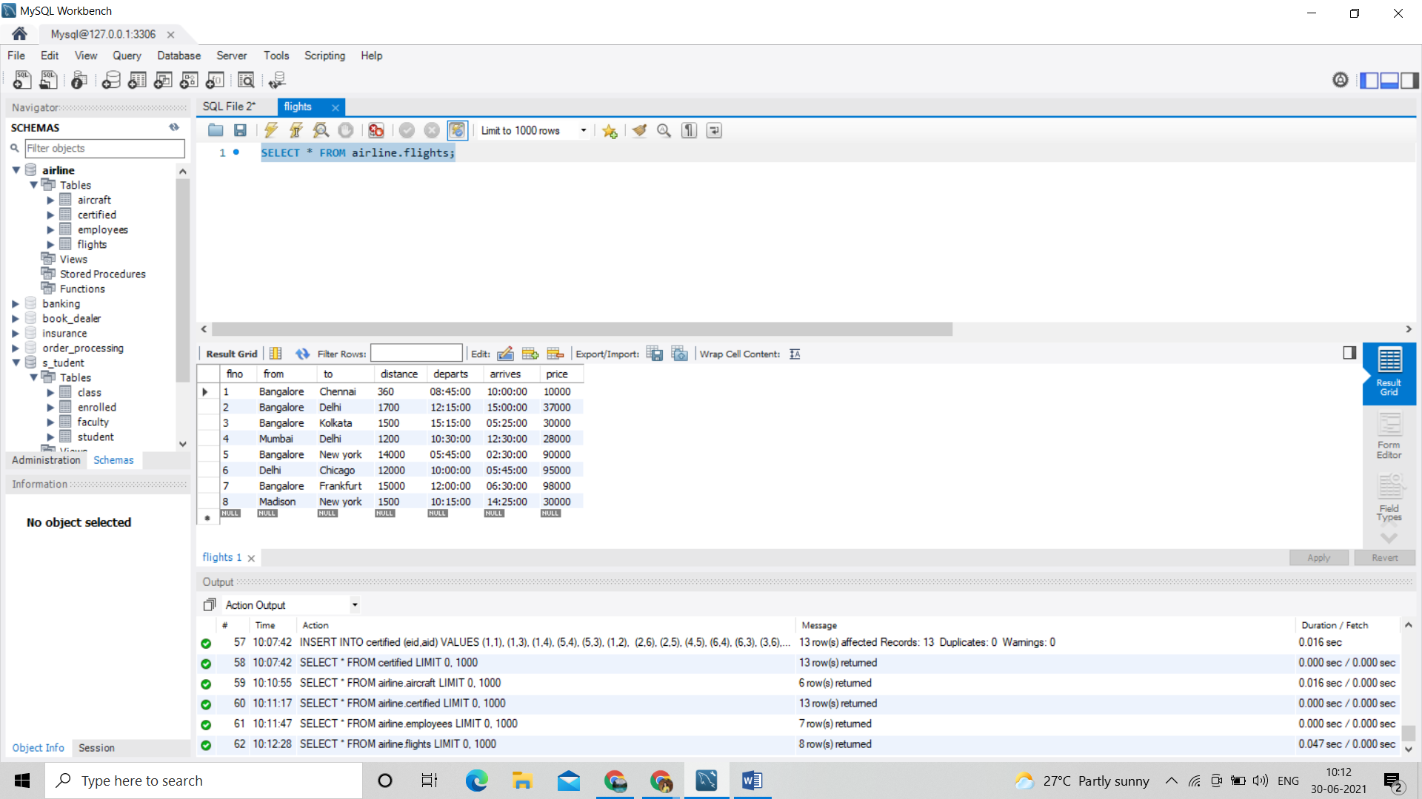

Quries:

/\*i. Find the names of aircraft such that all pilots certified to operate them have salaries more than Rs.80,000.\*/

SELECT DISTINCT A.aname

FROM Aircraft A

WHERE A.Aid IN (SELECT C.aid

FROM Certified C, Employees E

WHERE C.eid = E.eid AND

NOT EXISTS ( SELECT \*

FROM Employees E1

WHERE E1.eid = E.eid AND E1.salary < 80000 ));

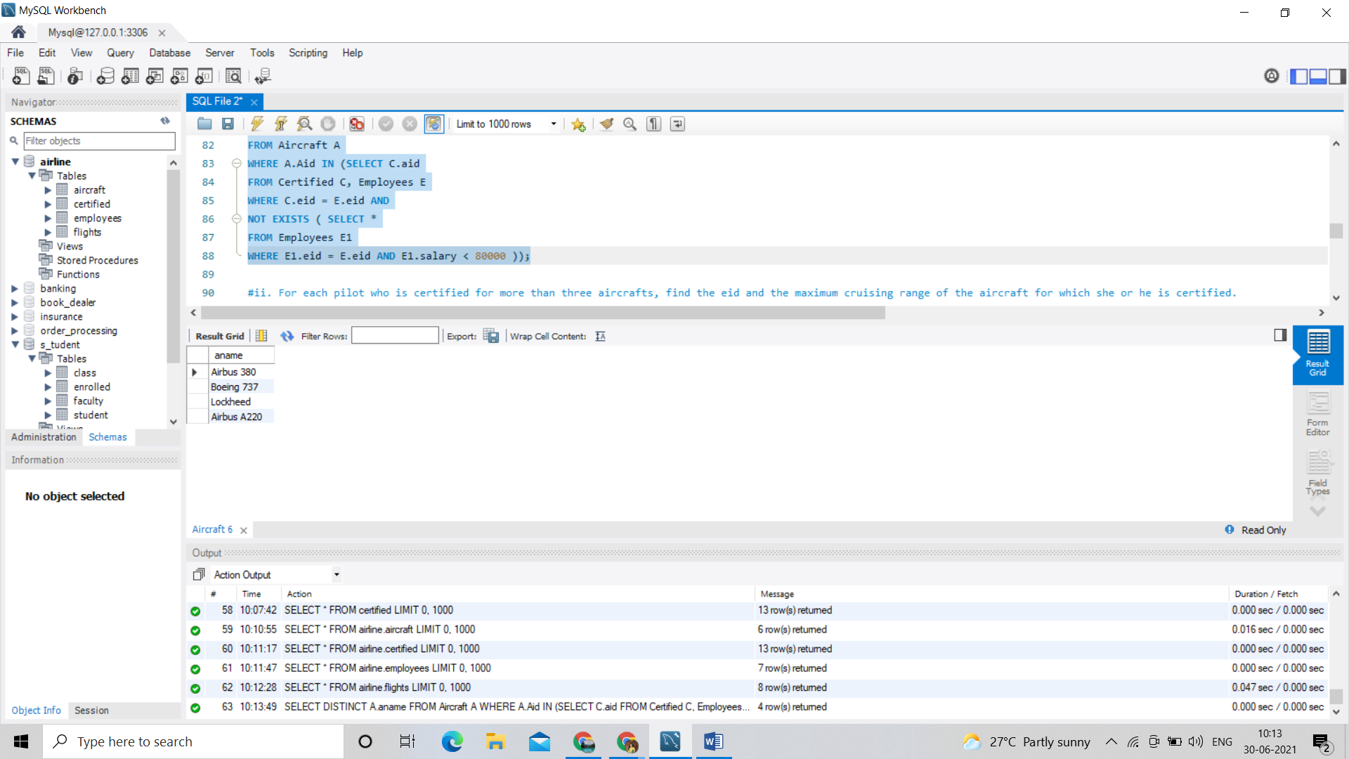

/\*ii. For each pilot who is certified for more than three aircrafts, find the eid and the maximum cruising range of the aircraft for which she or he is certified.\*/

SELECT C.eid, MAX(A.cruisingrange)

FROM Certified C, Aircraft A

WHERE C.aid = A.aid

GROUP BY C.eid

HAVING COUNT(\*) > 3;

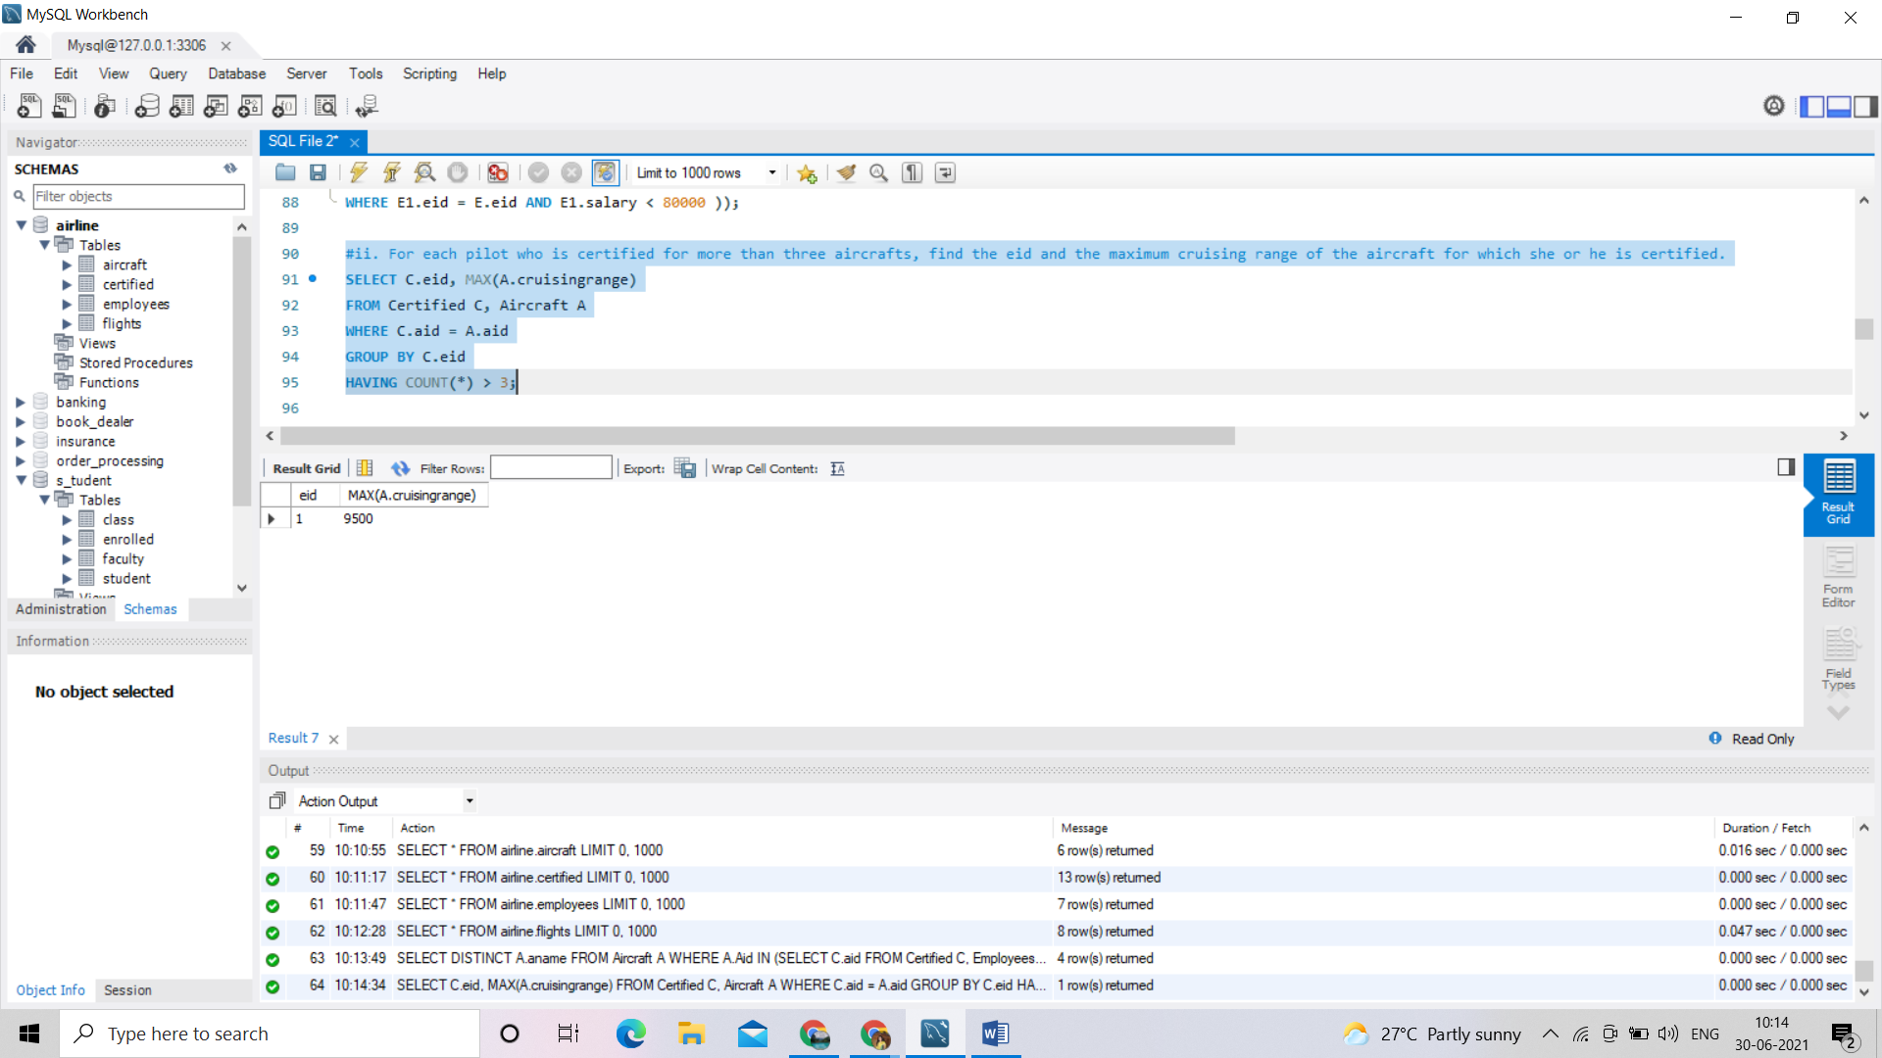

/\*iii. Find the names of pilots whose salary is less than the price of the cheapest route from Bengaluru toFrankfurt.\*/

SELECT DISTINCT e.ename

FROM employees e

WHERE e.salary<

(SELECT MIN(f.price)

FROM flights f

WHERE f.from='Bangalore' AND f.to='Frankfurt');

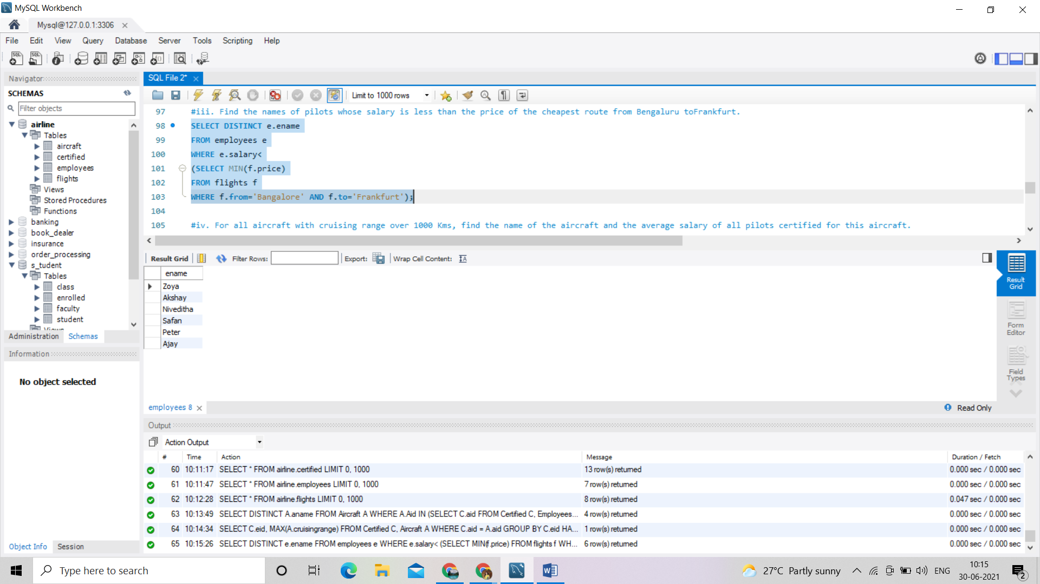

/\*iv. For all aircraft with cruising range over 1000 Kms, find the name of the aircraft and the average salary of all pilots certified for this aircraft. \*/

SELECT a.aid,a.aname,AVG(e.salary)

FROM aircraft a,certified c,employees e

WHERE a.aid=c.aid

AND c.eid=e.eid

AND a.cruisingrange>1000

GROUP BY a.aid,a.aname;

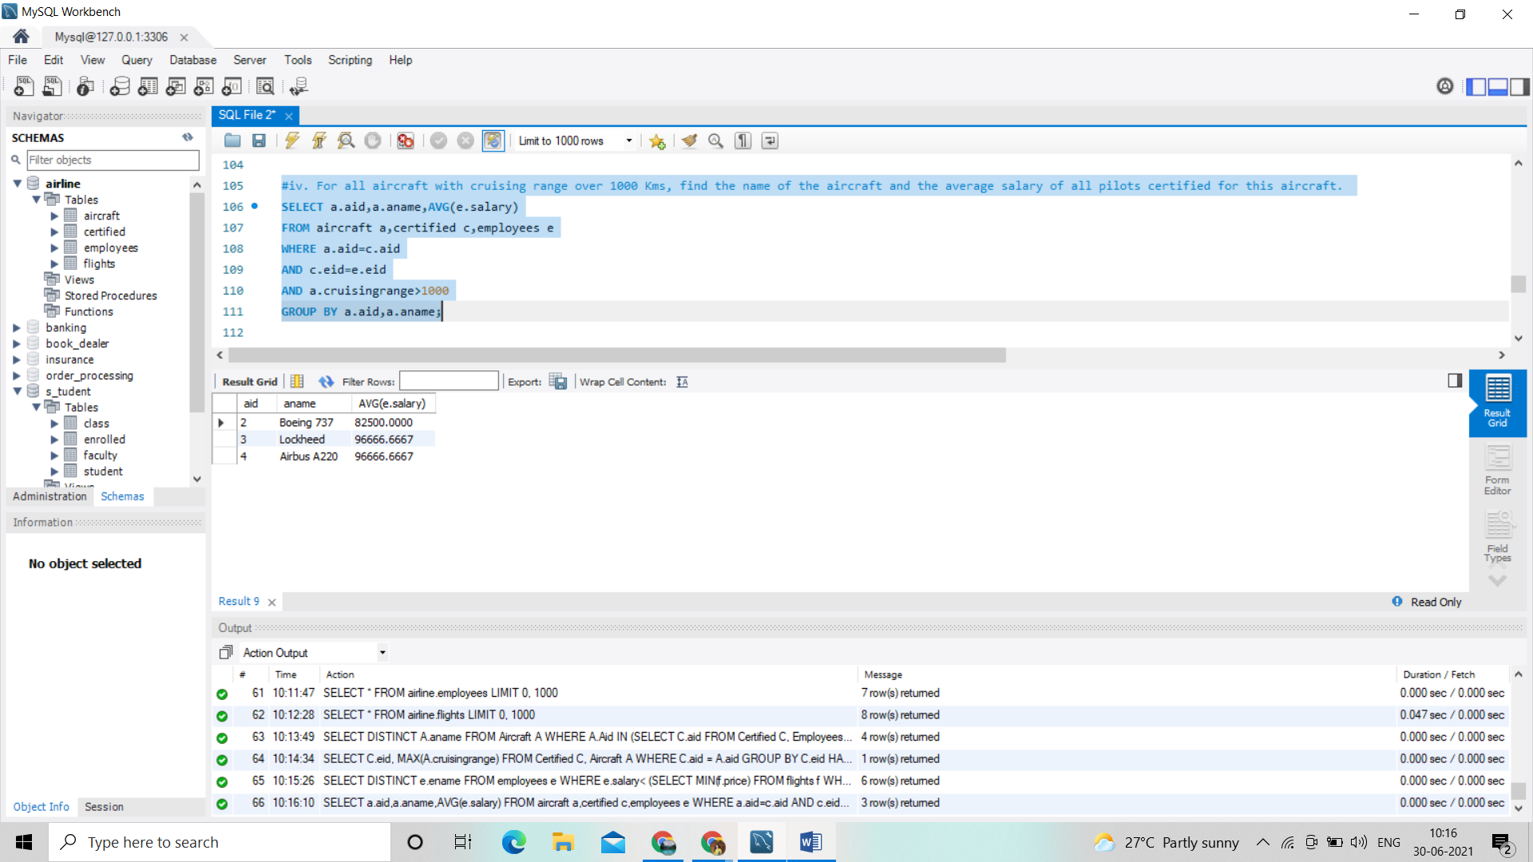

/\*v. Find the names of pilots certified for some Boeing aircraft. \*/

SELECT distinct e.ename

FROM employees e,aircraft a,certified c

WHERE e.eid=c.eid AND c.aid=a.aid AND a.aname like 'Boeing%';

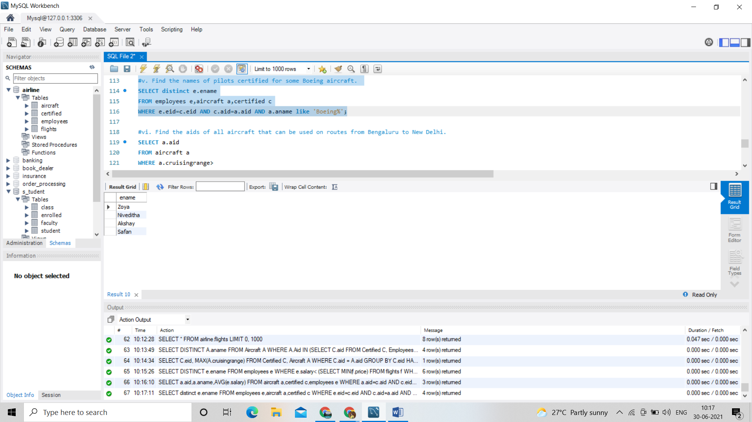

/\*vi. Find the aids of all aircraft that can be used on routes from Bengaluru to New Delhi. \*/

SELECT a.aid

FROM aircraft a

WHERE a.cruisingrange>

(SELECT MIN(f.distance)

FROM flights f

WHERE f.from='Bangalore' AND f.to='Delhi');

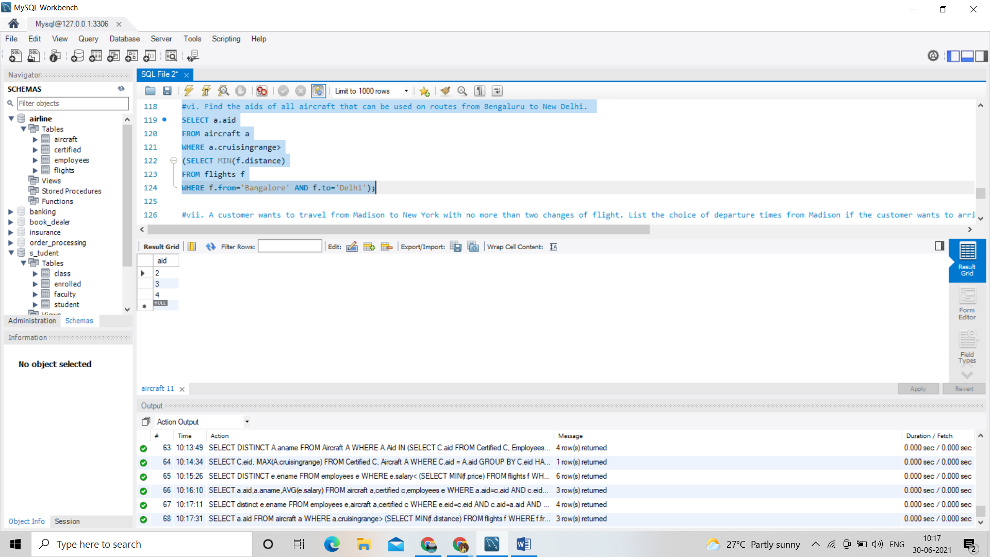

/\*vii. A customer wants to travel from Madison to New York with no more than two changes of flight. List the choice of departure times from Madison if the customer wants to arrive in New York by 6 p.m. \*/

SELECT F.departs

FROM Flights F WHERE F.flno IN ( SELECT F0.flno

FROM Flights F0

WHERE F0.from = 'Madison' AND F0.to = 'New york' AND F0.arrives < '18:00' );

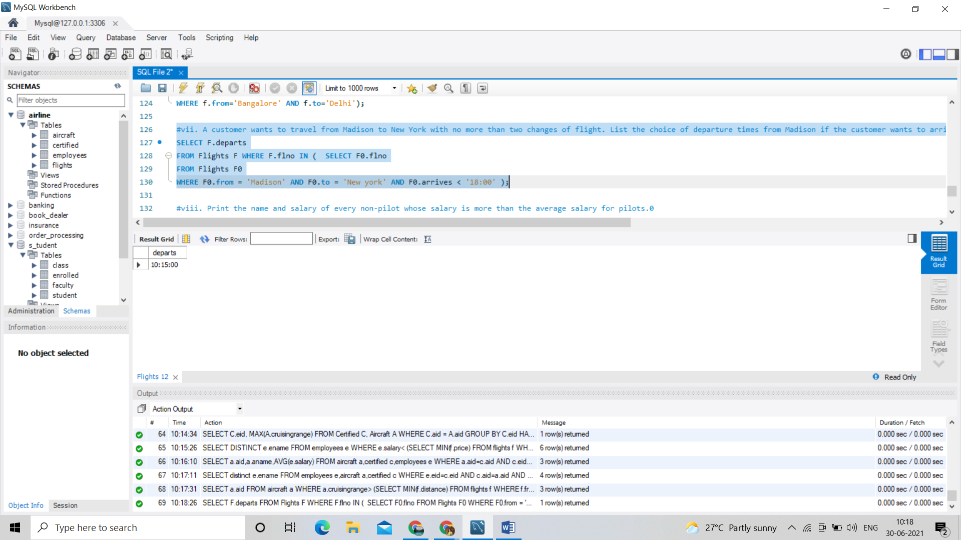

/\*viii. Print the name and salary of every non-pilot whose salary is more than the average salary for pilots.0\*/

SELECT E.ename, E.salary

FROM Employees E

WHERE E.eid NOT IN ( SELECT DISTINCT C.eid

FROM Certified C )

AND E.salary > ( SELECT AVG (E1.salary)

FROM Employees E1

WHERE E1.eid IN

( SELECT DISTINCT C1.eid

FROM Certified C1 ) );

